

**Lab Details**

1. In this Lab walkthrough, you will create a new Azure web app that runs a docker image using Azure CLI
2. Duration: **30 minutes**

**Introduction**

**What is Azure App Service?**

* Azure App Service is a collection of four services, which are built to help you host and run web applications.
* The four services are
  + Web Apps
  + Mobile Apps
  + API Apps
  + Logic Apps
* Although they look different, in the end, they all operate in very similar ways.
* Web Apps are the most commonly used.

**Architecture Diagram**

**Task Details**

1. Sign to Azure Portal.
2. Create a Web App using Azure CLI.
3. Get the Deployed App URL.
4. Test the deployment from the browser.
5. Validation test
6. Delete the Resources

# ****Lab Steps****

## ****Task 1: Sign in to Azure Portal****

1. Go to the Azure portal by using URL [https://portal.azure.com](https://portal.azure.com/).
2. Sign in with your **username** and **password** on Azure portal.

## ****Task 2: Create a Web App using Azure CLI****

1. First You have to click on the **Azure Cloud shell** icon in **Azure Portal.**

1. Click on **Bash.**

1. You have to fill in the details that are shown for mounting the storage account.
   * Cloud Shell region: Select **Central India**
   * Storage Account:Select **create new** and Entera globally unique name
   * File Share: Select **create new** and Enter a file share name
2. After Filling in all the details, **click** on **Create Storage** and wait for some time.
3. Now you have your **Bash** terminal running. please **ignore the warning message.**
4. Now for creating a web app in Azure,first you have to create an app service plan. use the **below command** to create **App Service Plan.  
     Note: Replace**<resource group name> with the **already provided resource group name**.

az appservice plan create --name <App service plan name> --resource-group <resource group name>

1. Now use the below command to **create a web app** in azure.  
     **Note:** Entera **globally unique** web app name.

az webapp create --resource-group <resource group name> --plan <App service plan name> --name <web app name>

1. After executing the commands wait for some time until the **app service plan** and **web app** is **created.**

## ****Task 3: Get the Deployed App URL****

1. Click on **App services** in the left-hand panel of the **Azure portal menu.**

1. **Select** the **WebApp** that you have created.

1. Interfaz de usuario gráfica, Texto, Aplicación, Correo electrónico

   Descripción generada automáticamenteNow **copy the url** of your **web app** and **paste** it in a **new tab.**

## ****Task 4: Test the deployment from the browser****

1. Interfaz de usuario gráfica, Texto, Aplicación

   Descripción generada automáticamenteYou will see the below page after navigating to the Web App URL in the browser.

1. Switch back to the **Overview Page** of Web App Created. If you **scroll down**, You can see **several charts**.

### **Do You Know?**

CLI commands can be executed faster than their graphical counterparts, making them popular among power users, developers, and system administrators who prefer efficiency and automation.

## ****Task 6: Delete the Resources****

1. In the search box at the top of the Azure portal, enter **Resource groups**. Select **Resource groups** from the search results.
2. Click on the name of **Resource groups**

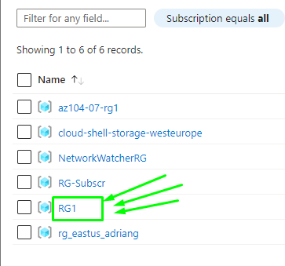

1. Now type **delete**
2. Confirm delete

# ****Completion and Conclusions****

1. You have successfully signed into Azure portal.
2. You have Successfully Understood how to create a New Web App using Azure CLI
3. You have successfully got the web app URL.
4. You have successfully tested the web app URL from the browser.
5. You have successfully tested the validation.
6. You have successfully deleted the resources.